 |  |  |  |  |  |  |  | 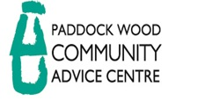
 |  | Internal Client Complaints Form
The Paddock Wood Community Advice Centre welcomes all types of feedback from our clients so we can try and improve our services to meet our client’s needs. All complaints made will be treated fairly and be dealt with in a timely manner and used to improve services if necessary.

This form provides a route by which customers can express a complaint.
 | Clients Details
 | Name
 | Address
 | Phone Number
 | Email Address
 | Clients Complaint
 | Desired Outcome
 | Date |  |  |  |  | Clients Signature

